

**Submitted by: Submitted to:**

**NAME: Rahul Gusain Hitesh Kumar Sharma**   
 **SAP: 500084143**  
 **ROLL NO.: R214220900**  
 **BATCH: 1 DevOps**

EXPERIMENT 6

**AIM:**  
**Working with Docker Compose File to Control Multiple Containers**

**Steps to Complete:**

# **Creating compose files**

* Create a directory named nginx in your root.

mkdir nginx

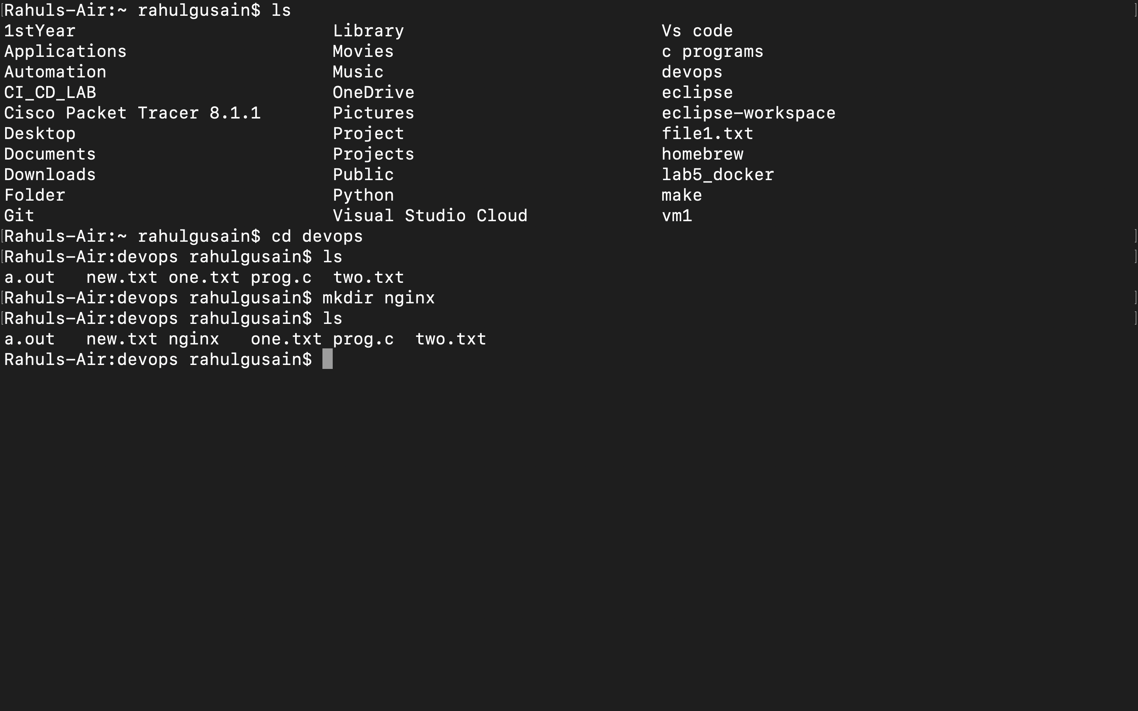

* Switch to that directory and create a file named docker-compose.yaml

cd nginx

vi docker-compose.yml

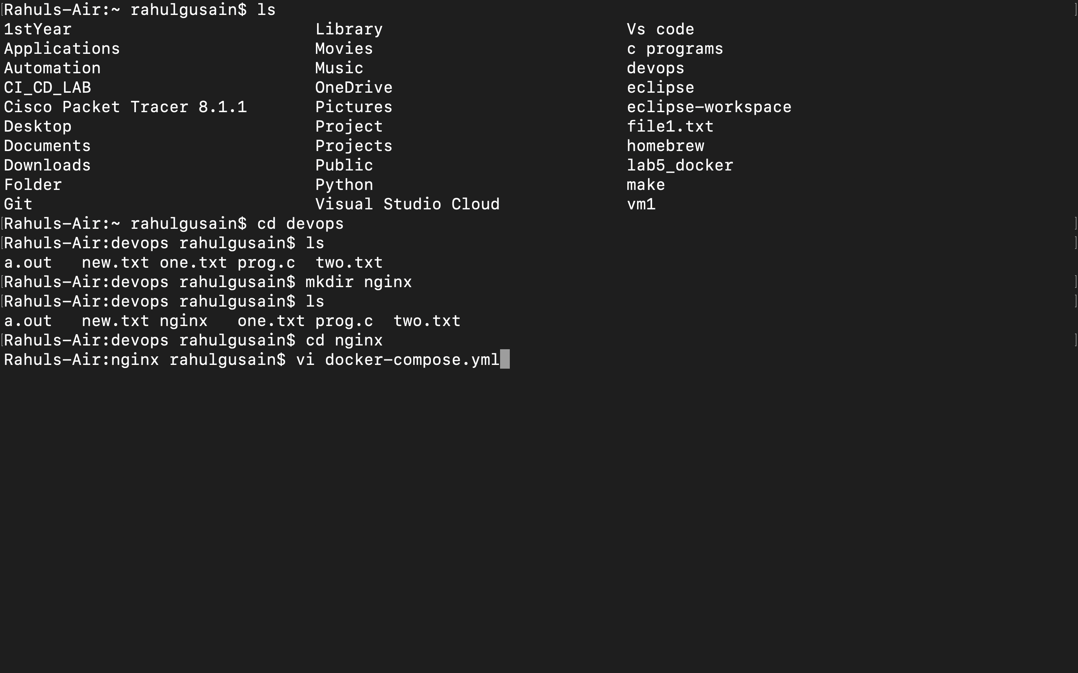

* Use docker-compose version 2 to create docker-compose.yaml file. Create a service named "databases". Use image named "mysql" Map container 3306 port to host machine 3306 port.

Add environment variables named "MYSQL_ROOT_PASSWORD",

"MYSQL_DATABASE", "MYSQL_USER" and "MYSQL_PASSWORD" along with corresponding values for all.

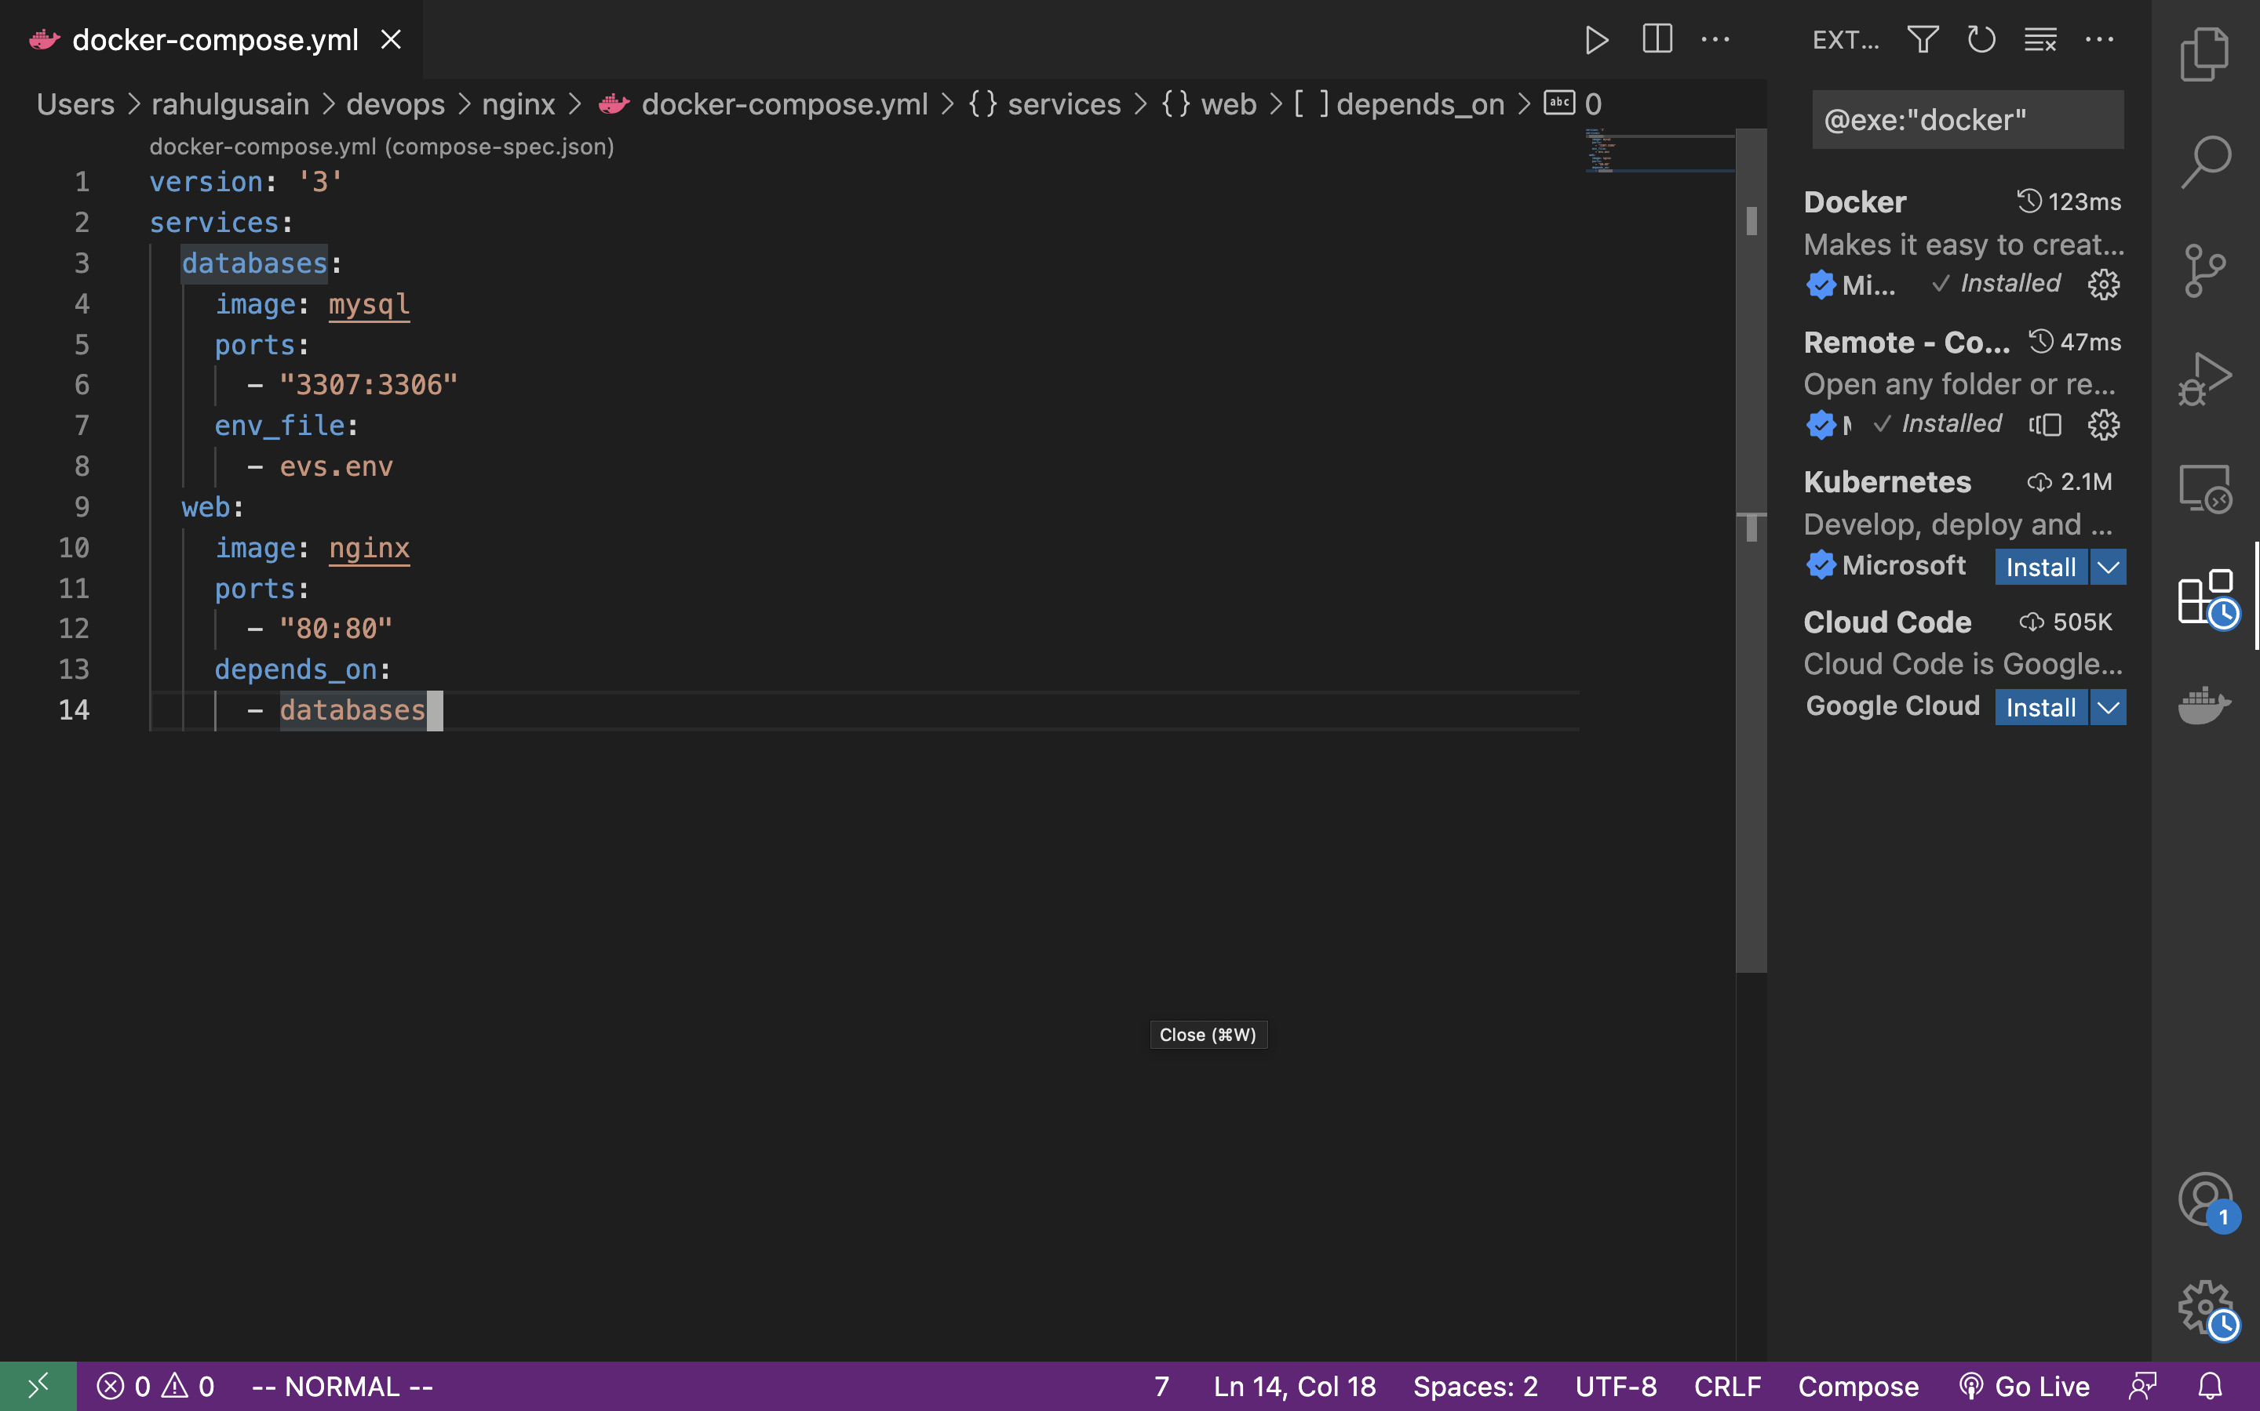

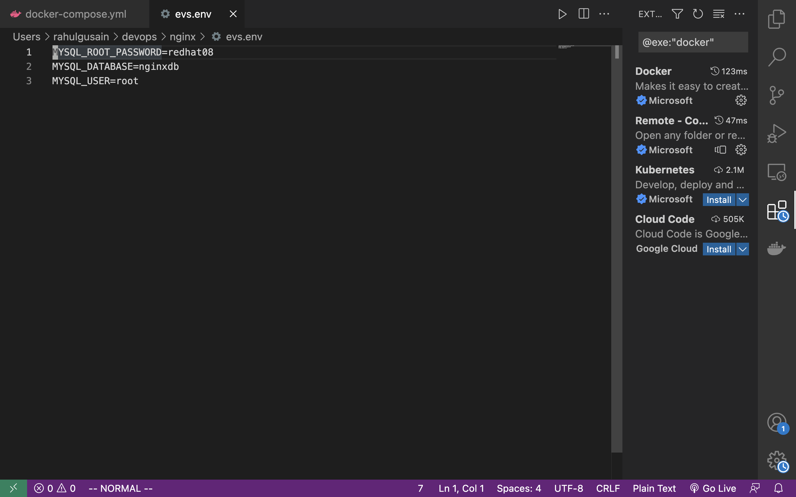

cat evs.env

MYSQL_ROOT_PASSWORD=redhat08

MYSQL_DATABASE=nginxdb

MYSQL_USER=root

Add another service named "web" Use image "nginx"

cat docker-compose.yml

version: '3' services: databases: image: mysql ports: - "3307:3306" env_file: - evs.env web:

image: nginx

ports: - "80:80" depends_on:

- databases

# **Running images using docker-compose**

* Save docker-compose.yaml file and do docker-compose up.

docker-compose up –d

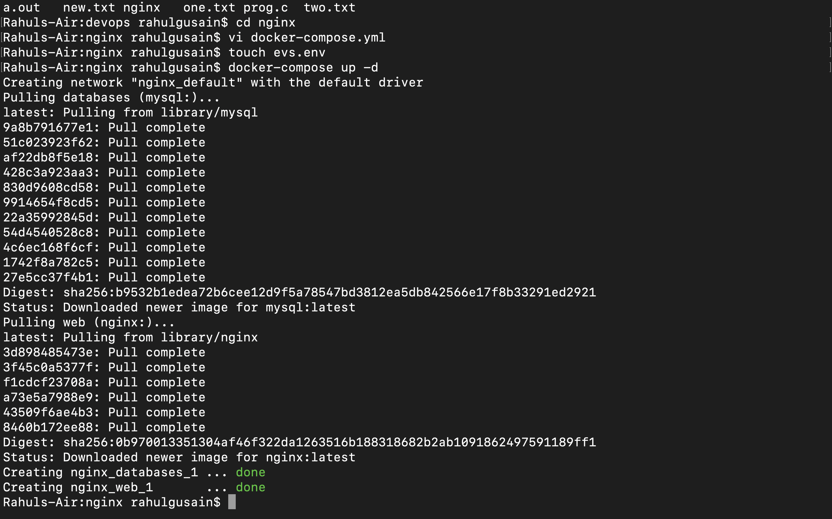

* Verify nginx service is up and is accessible on machine.

curl localhost:80

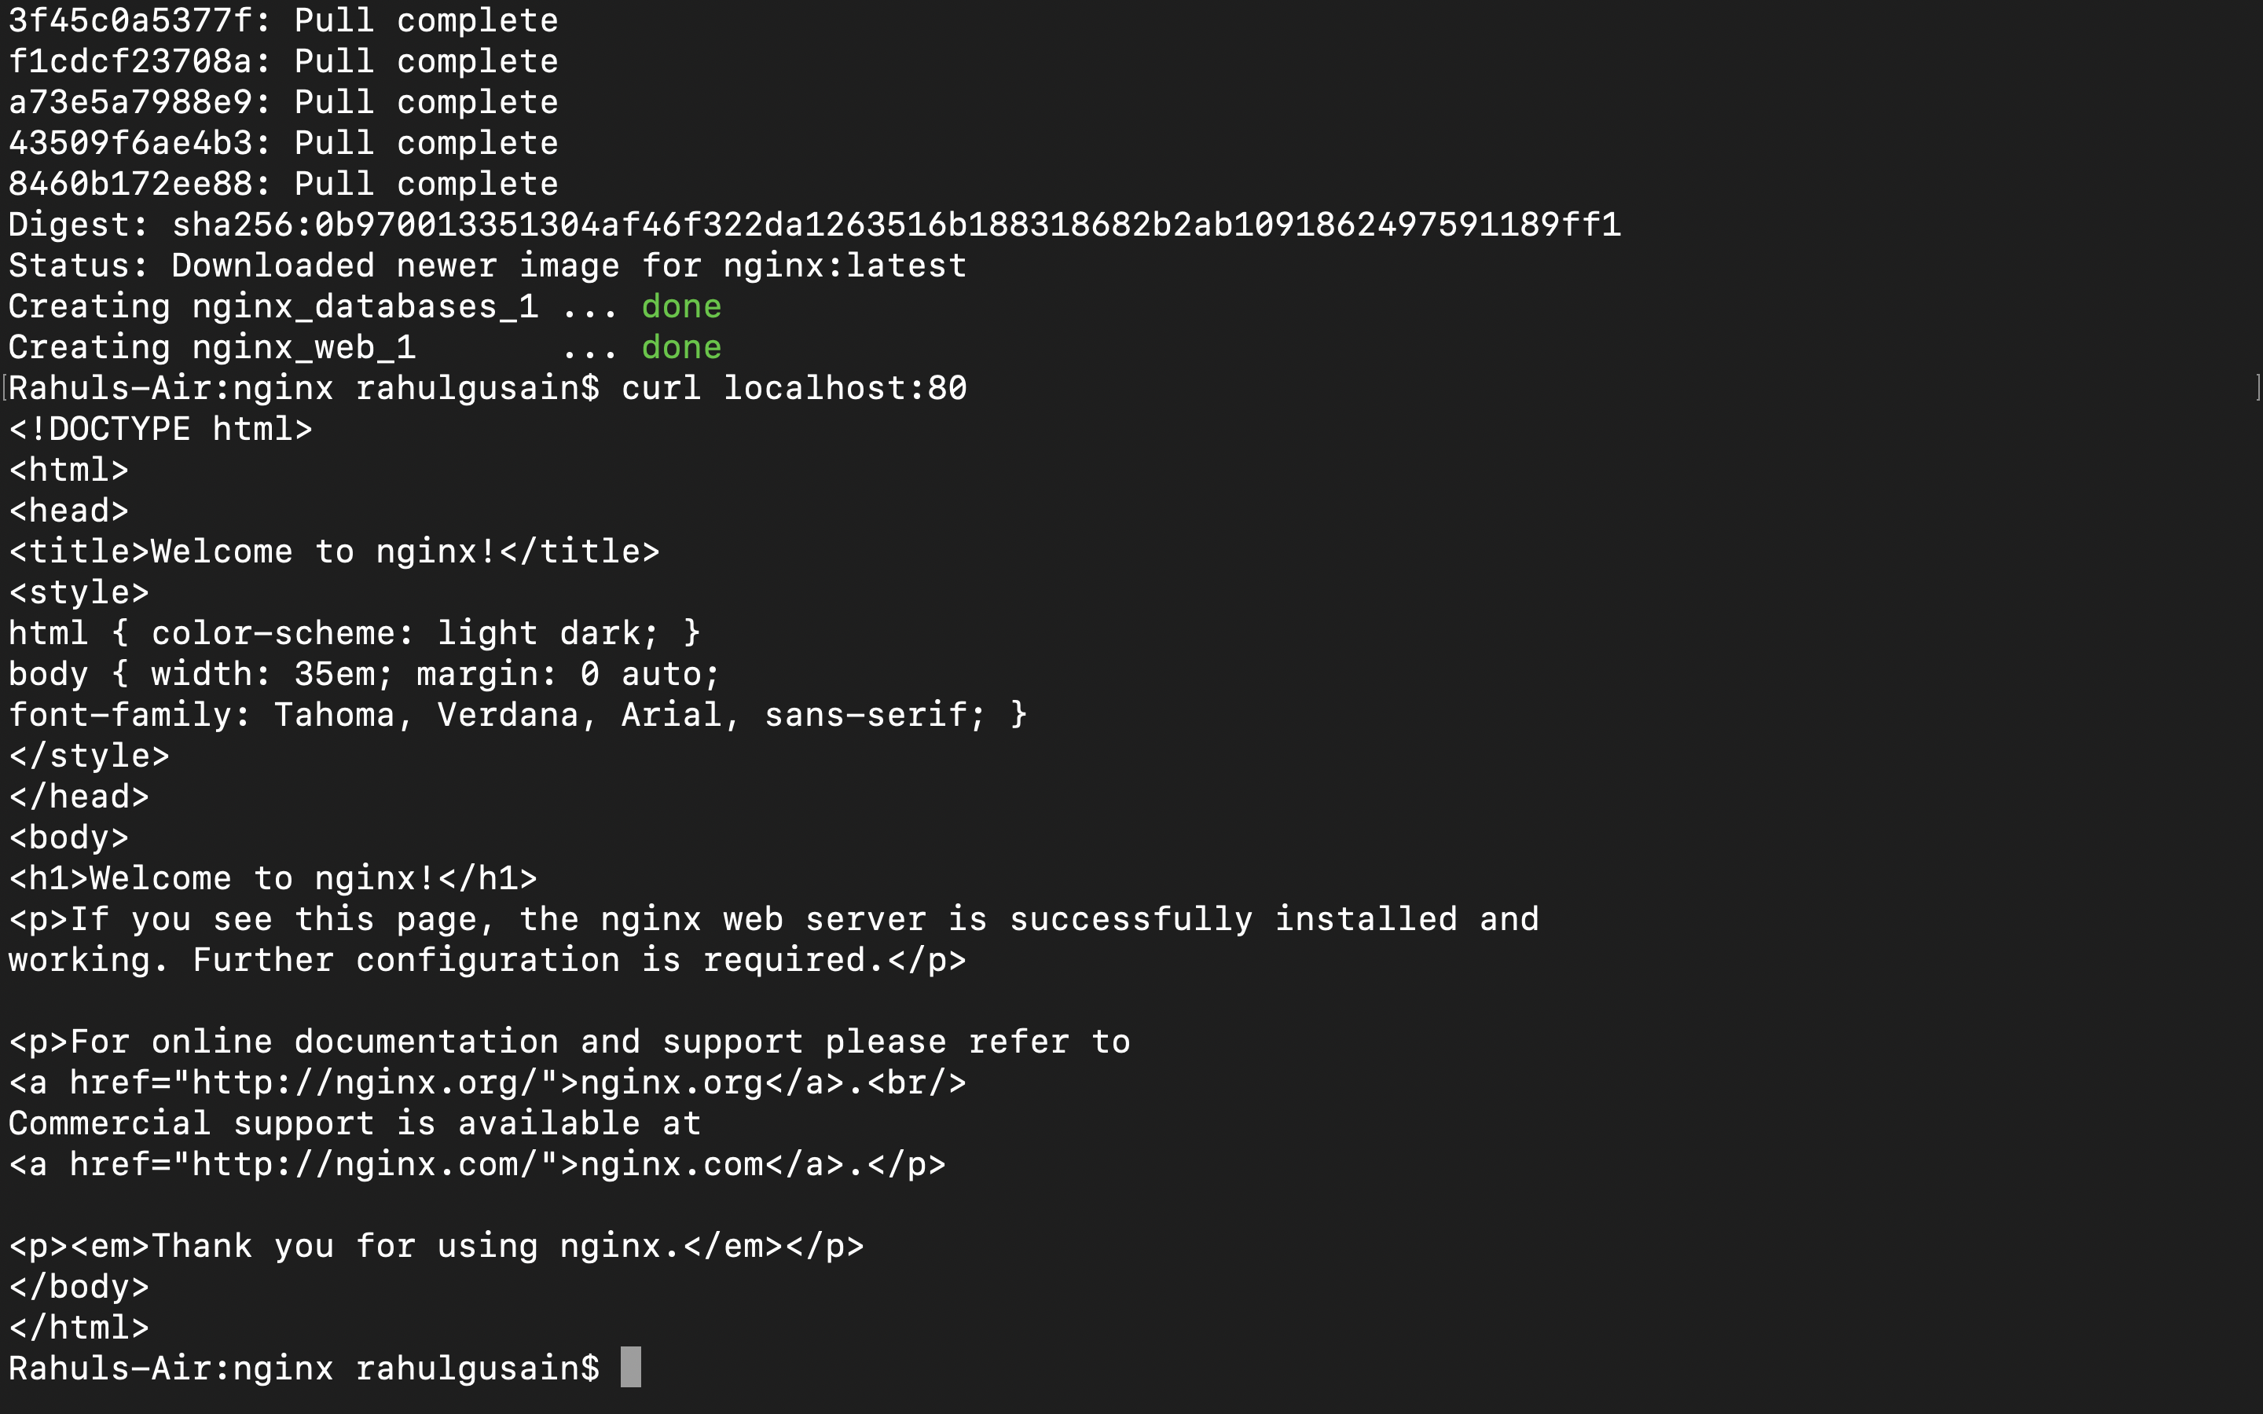

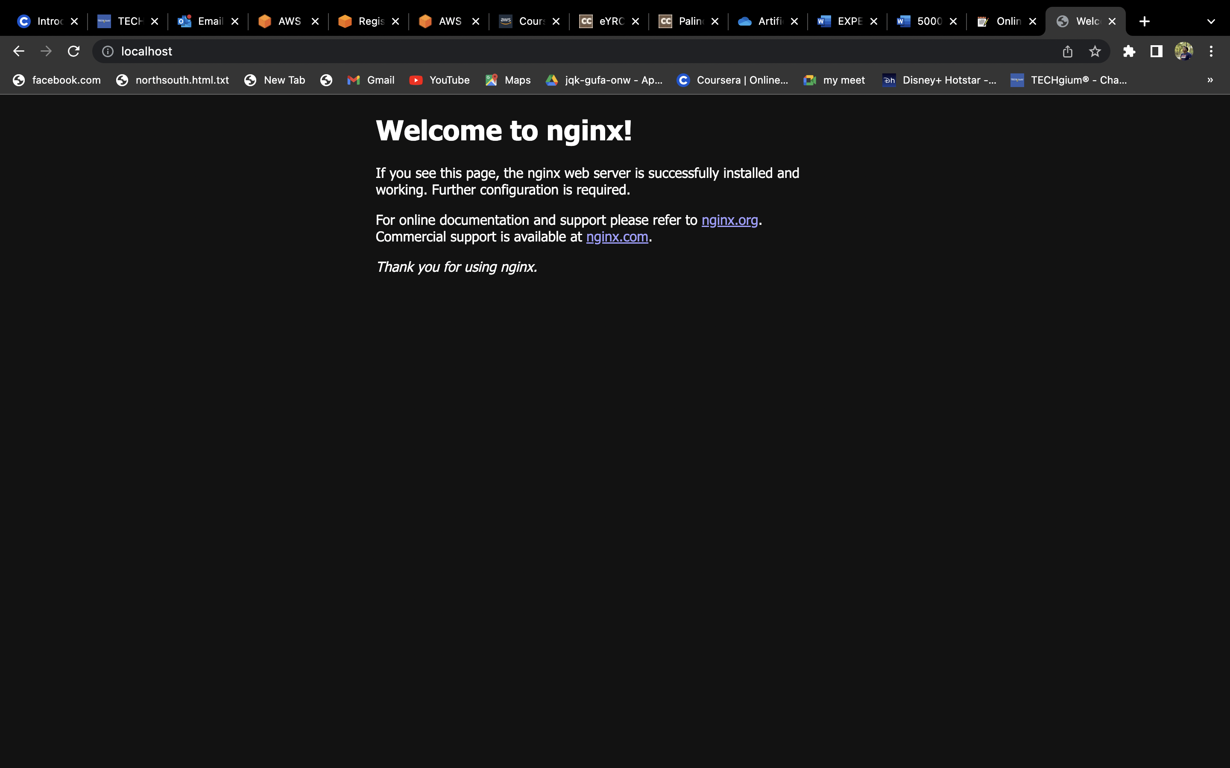

Stop and remove your docker container using docker-compose.

docker-compose down

